Washing Hands

Materials Needed:
- Hand Washing Station (Kitchen Sink)
- Dishes
- Dish Soap
- Sponge
- Task Analysis ( Inserted Below)
- CLC Hand Washing Video

Introduction/ Discussion:
Learning to wash dishes has numerous benefits that help create independence,Problem solving skills all while encouraging cleanliness, discipline and helps them feel as though they are contributing to daily household tasks and chores.

Activities:
- Discuss the activity for the day and why it is important.
- Model the task
- Have the student complete the task, independently or with /prompt support.
- Hand Washing Other items Ex: Pots,Pans,Cups,Tupperware
- Practice Cleaning and drying the sink area.

Wash the dishes
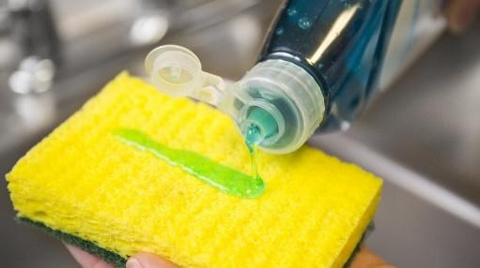 Put a little bit of soap on the sponge.

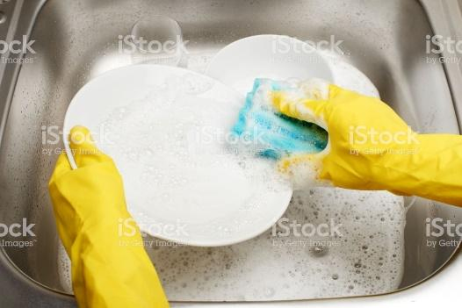 Scrub the front of the dish until it is covered with soap.

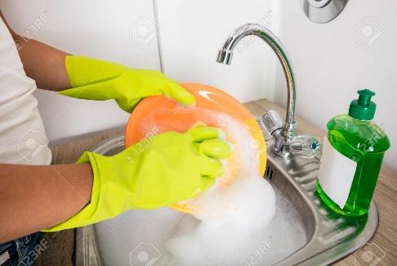 Scrub the back of the dish until it is covered with soap.

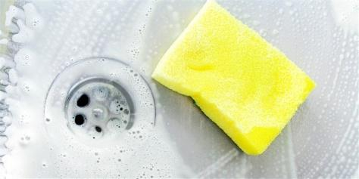 Put the sponge on the counter.

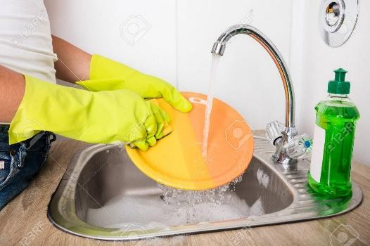 Rinse the front and back until no more soap is on the dish.

